Project Report

Cryptocurrency Volatility Prediction

1. Project Overview
This project aims to predict the volatility (risk level) of Bitcoin using historical market data. Predicting volatility is crucial for traders and investors to manage risk, as it indicates how much the price of an asset is likely to fluctuate over a specific period.
2. Technical Stack
- Language: Python
- Data Analysis: Pandas, NumPy
- Visualization: Matplotlib, Seaborn
- Machine Learning: Scikit-learn (Random Forest Regressor)
- Deployment: Streamlit (Web Interface)

3. Methodology
The project follows a structured Machine Learning pipeline:
- Exploratory Data Analysis (EDA): Analyzing price trends and identifying correlations between features like Volume, RSI, and Market Cap.
- Feature Engineering: Creating technical indicators such as the Relative Strength Index (RSI) and Volatility Lags to improve prediction accuracy.
- Model Development: Training a Random Forest Regressor to learn patterns from historical data.
- Deployment: Building a local web application where users can input market parameters to get real-time volatility predictions.

4. System Architecture
High-Level Design (HLD) Flow
- The HLD represents the end-to-end journey of the data within the system:
- Data Ingestion: The process of loading the Bitcoin historical dataset from a structured CSV file into the environment.
- Feature Engineering: Transforming raw price data into technical indicators like RSI and Volatility Lags to improve model intelligence.
- Model Training: Utilizing the Random Forest Regressor algorithm to learn patterns and correlations within the data.
- Deployment: Launching the interactive Streamlit Dashboard to provide a user-friendly interface for real-time predictions.

Low-Level Design (LLD) Details
The LLD focuses on the specific logic and technical steps implemented in the code:
- Data Cleaning Logic: * Removing null values using .dropna().
  - Handling inf (infinity) values to prevent mathematical errors during training.
- Mathematical Indicators: * RSI: Calculated over a 14-day window to monitor momentum.
  - Volatility: Calculated as the standard deviation of returns to quantify market risk.
- Algorithm Configuration: * Implementing a Random Forest Regressor with 100 estimators (trees) to ensure stable and robust predictions.
  - Applying an 80-20 Train-Test Split to validate the model on unseen data.
- UI Integration: * Using Streamlit "Sidebar Sliders" to capture user inputs.
  - Mapping user inputs to the model's feature names for instant prediction output.
- .

5. Key Results & Visualizations
A. Correlation Heatmap
- Description: This chart shows the relationship between different features.
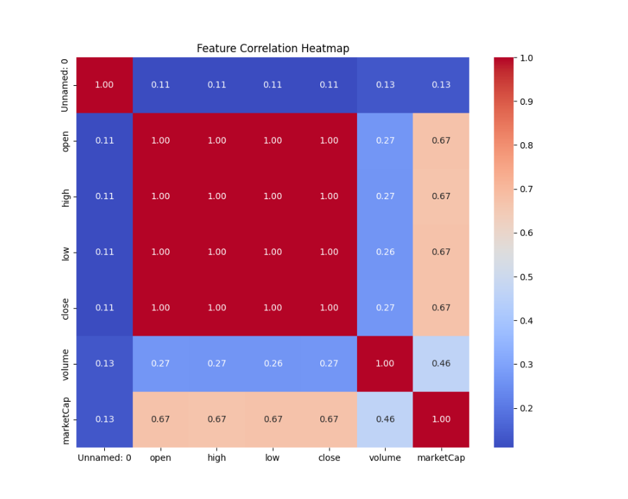
B. Bitcoin Price Trend
- Description: A time-series visualization showing the historical closing price of Bitcoin.
- 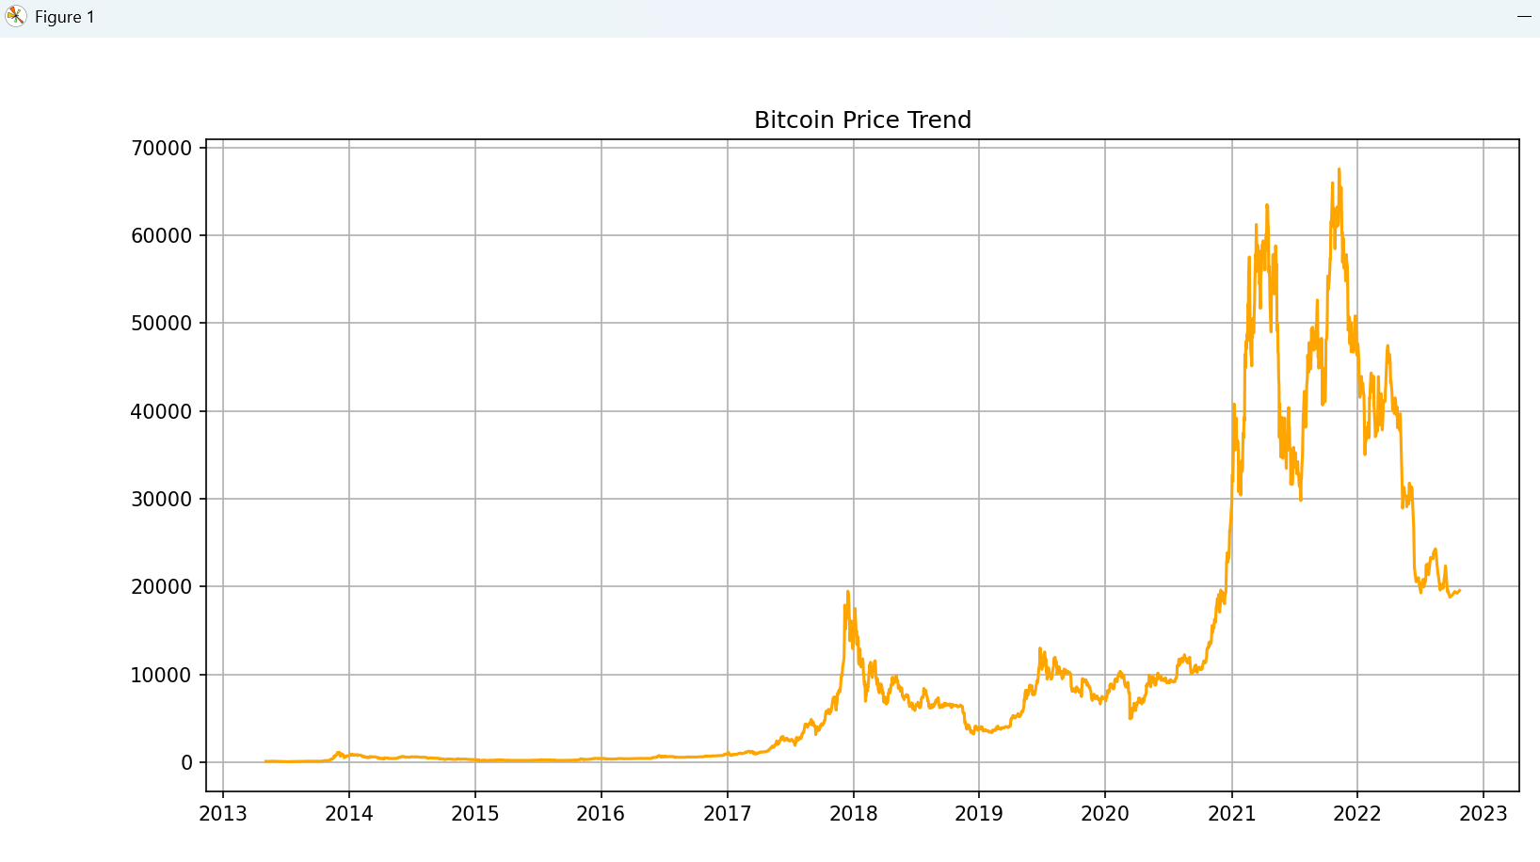
C. Model Performance
- Algorithm: Random Forest Regressor
- R² Score: 0.3695 (This indicates the percentage of variance the model can explain).
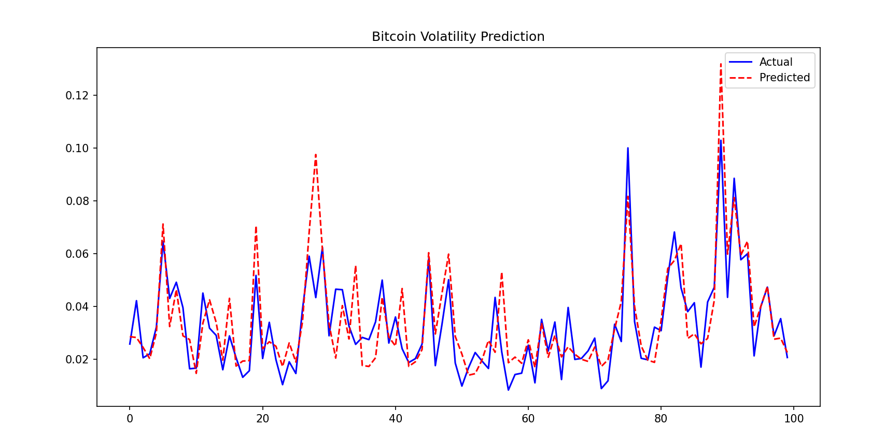
D. Interactive Web Interface
- Description: The final Streamlit dashboard allows users to adjust sliders for Return, RSI, and Lagged Volatility to predict future risk.
- 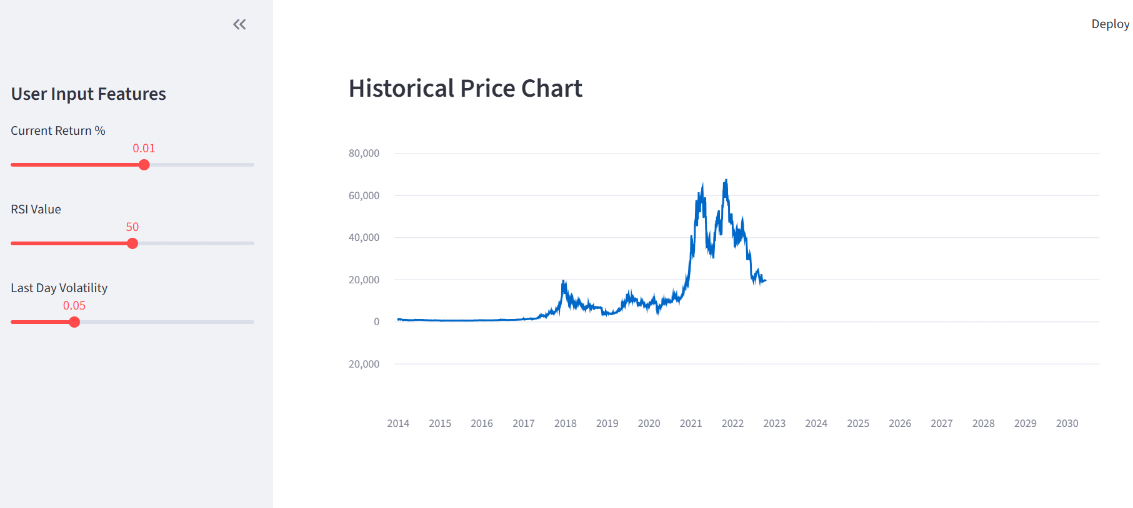

6. Conclusion
The project successfully demonstrates the use of Machine Learning to quantify financial risk. By combining technical indicators with ensemble learning, the system provides a functional tool for volatility forecasting. This can be further improved by adding sentiment analysis or deep learning models (LSTM) in the future.

